What are the differences in motivation during treatment with an eCoach and regular treatment?

A problem with traditional eHealthcare and self-management is that patients lose motivation over time. They begin with good will since they’ve just decided to start fighting their anxiety. The decision to start treatment is rather heavy, so once the choice is made to start treatment, the patients are motivated to do their absolute best to change their selves. But it is shown[1] that this motivation slowly degenerates as the treatment progresses. Patients fill in the forms required for the treatment less often and stop the treatment altogether. The same study says that physical interventions during the treatment period refreshed the motivation.

Physical interventions bring their own trouble with them since they require people to actively involve themselves with others. But an eCoach can fill in the same role. With an eCoach, or Computer Assistant, the patients stay more motivated over the duration of the treatment. This is illustrated in the image below, which is taken from a study on the effects of a computer assistant on a plan for weight loss.[2]

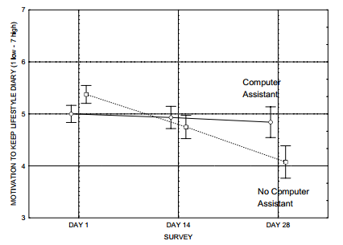

Other than the patients being more active with filling in the results of their treatment, the same study shows that the patients also are more willing to actively achieve the goals set for them, when an eCoach is supporting and motivating them. This is illustrated below.

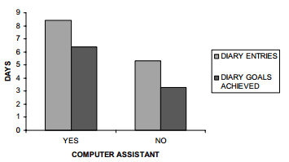

These results show that there is a significant difference in the motivation levels of patients during treatment with an eCoach and without. This is especially noticeable in the later stages of the program.

1. L.L. Alpay, R.I. Overberg and J.H.M. Zwetsloot-Schonk. Empowering Citizens in Assessing Health Related Websites: A Driving Force for Healthcare overnance, International Journal of Healthcare Technology and Management (IJHTM), Special issue: “Governing ICT in healthcare and governing healthcare with ICT” 8(1/2) (2007), 141–160.
2. O. A. Blanson Henkemans, P. J. van der Boog, J. Lindenberg, C. A. van der Mast, M. A. Neerincx, and B. J. Zwetsloot-Schonk,*An online lifestyle diary with a persuasive computer assistant providing feedback on self-management*, *Technol Health Care,*vol. 17, pp. 253-67, 2009.